Simple Monopoly Game Developer manual

Check the version of Java:

In the command line, type java -version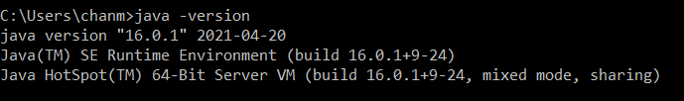

java version "16.0.1" 2021-04-20

Java(TM) SE Runtime Environment (build 16.0.1+9-24)

Java HotSpot(TM) 64-Bit Server VM (build 16.0.1+9-24, mixed mode, sharing)

The version of Java should be 16.0.1 or higher.

How to compile the code:

1. Open cmd

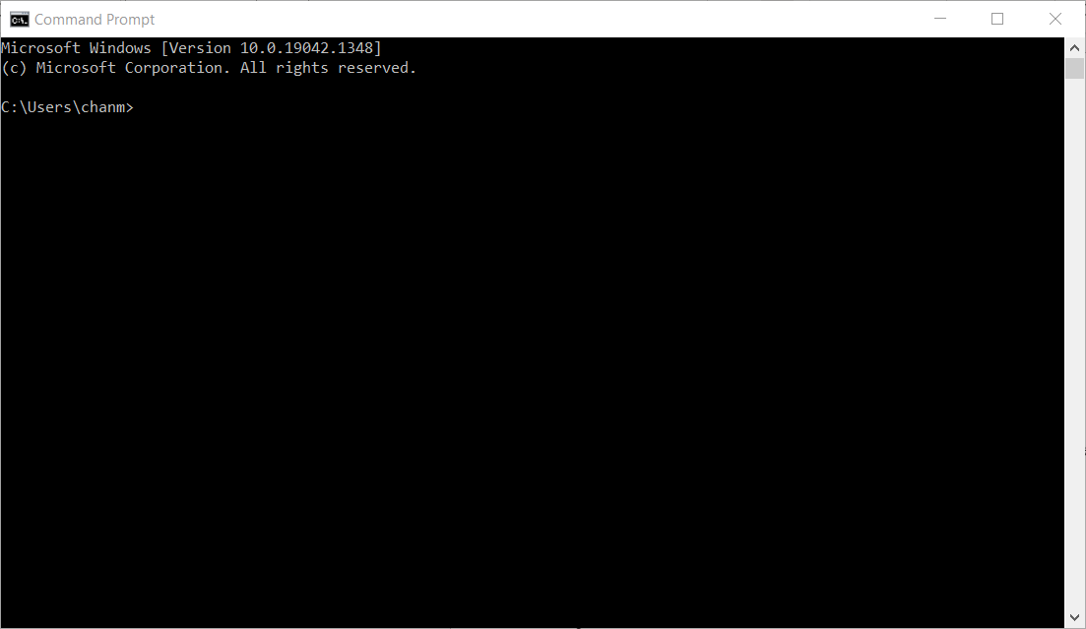

1. Go to the directory where the game files are stored
2. Type “cd directory” (in the example, cd Desktop\class\game)

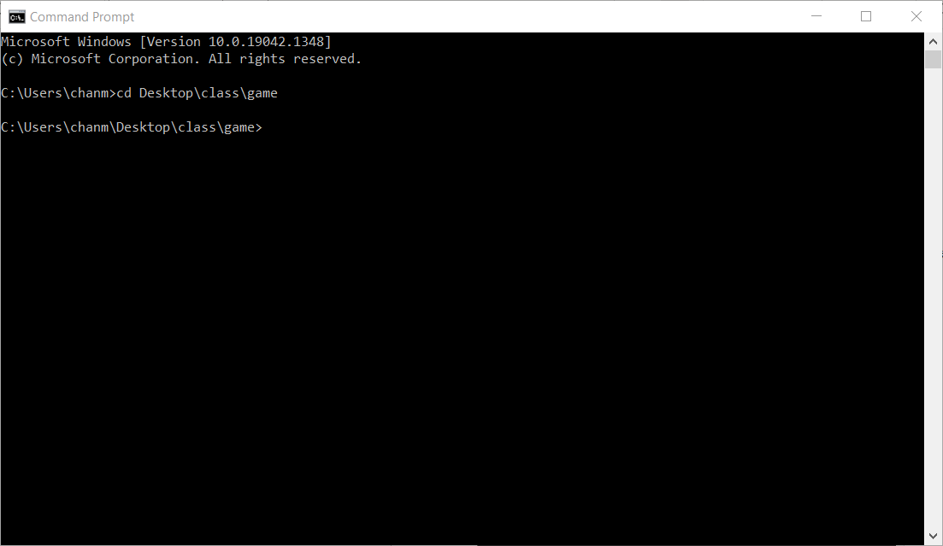

1. Type “javac Menu.java” and press enter to compile the code

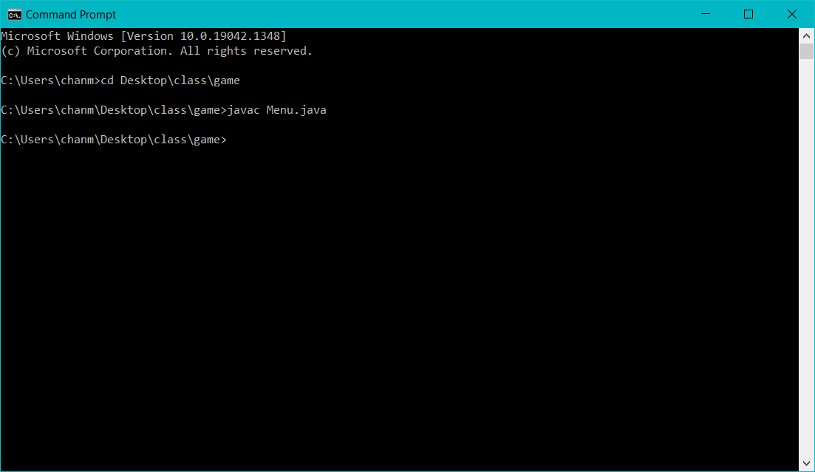

1. .class files will be generated in the same folder

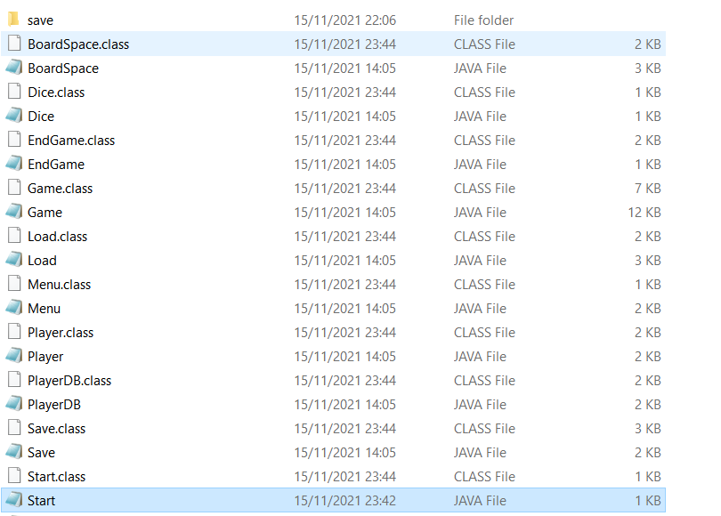

How to build the project:

1. Type “java Menu” to run the program

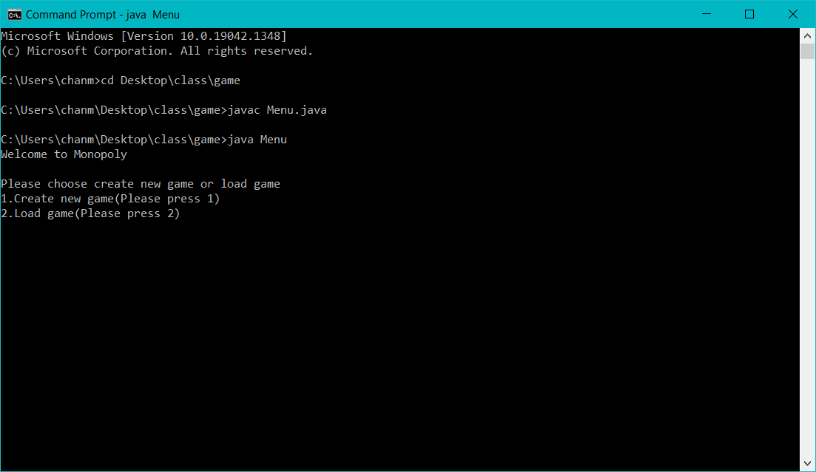

1. The game starts automatically